**Nagaland**

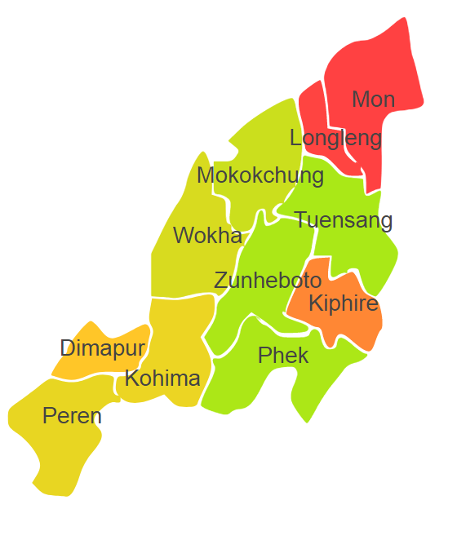

Manipur comprises of one Agro Ecological Region (AER) 17.

**Agro-Eco Region 17:** AER 17 in Nagaland comprises of Dimapur, Kiphire, Kohima, Longleng, Mokokuchung, Mon, Peren, Tuensang, Wokha and Zunheboto districts North-eastern Hills (Purvachal) under Agro Ecological Sub Regions (AESR)17.1 & 17.2.